Rajib Bhattacharya

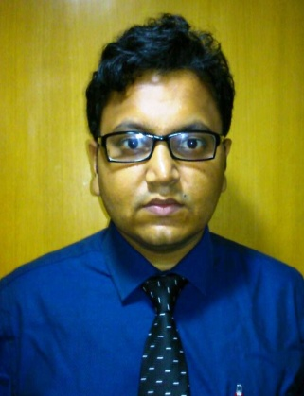

37 RUSSA ROAD, TOLLYGUNGE, KOLKATA-700033

**Mobile:** [9830630744] **E-mail:** [rajibbhattacharya5@gmail.com]

Personal ProfileSummary of Qualifications

* Bachelors Degree in B.Sc
* Excellent Computer knowledge
* Superior knowledge in dealing with the internet and email
* Huge understand for the following operating systems- Windows XP, Vista, Windows 7
* Impressive communication and interpersonal skills
* Excellent Good organization and presentation skills
* People oriented
* Impressive analytical and statistical skills
* Honest and hardworking with proven dedication to adhere to work ethics

Achievements

* Successfully meet the objective and goal of the bank by formulating business plans and sales strategies

Career Summary

• Having 2+ years of experience in the field of banking

• Providing solution to the customer’s problems

• Selling insurance policies to the customers and giving them after sale services

• Providing banking solutions to the rising needs of the customers

Education

**2005** [MP/10th][W.B.S.E]

**Grade achieved: [2nd]**

**2007** [HS/ 12th] [W.B.C.H.S.E.]

**Grade achieved: [2nd]**

**2012** [B.Sc.] [Kalyani university.]

**Grade achieved: [2nd]**

**[2008]** [DITA in Computer] [Y.C.T.C]

**Grade achieved: [1st]**

**Professional Exprince**

**[MAY/13 - FEB/14] [BSO] [HDFC BANK LTD.]- KHANNA BRANCH.**

* Sales of Retail, Asset products and TPP
* Enhancing customer wallet size and customer services
* Documentation for all account opening and all customer instructions
* .

**[FEB/14 – TILL NOW] [OS] [AXIS BANK LTD.] – PRINCE ANWAR SHAH**

**BRANCH.**

* Responsible to deal with investments and new accounts everyday.
* Responsible for directing the use of latest idea and procedures hence increasing the client services at higher rates.
* Responsibilities: To promote & sale Retail Banking product i.e. Savings, Current, NRI, DEMAT,

Trading Recurring Deposit, Fixed Deposit, EDC (Electronic Data Capture) Machine et al.  and Mutual Funds, SIP (Systematic Investment Plan), General Insurance and Life Insurance.

**Personal Details**

Date of Birth: 07th, Oct 1989  
Languages Known: Bengali, English, Hindi  
Nationality: Indian